Queries and Functional Dependencies of Flickr.com(Part-2)

Group No. 28

Kirnesh Nandan (13312009)

Mohak Garg (13312013)

Rahul Jain(13311016)

Mithilesh Kumar(13312012)

|  |  |  |  |
| --- | --- | --- | --- |
| Table | Functional Dependency | Minimal Cover | Candidate Keys |
| User Table | User_ID->  Name,Password,Web_Address  Web_Address->User_ID | User_ID->Name  User_ID->Password  User_ID->Web_Address  Web_Address->User_ID | {User_ID},  {Web_Address} |
| Album Table | Album_ID->  Album_Name,Owner_User_Id,  Date_Created,Description | Album_ID->Album_Name  Album_ID->Owner_User_ID  Album_ID->Date_Created  Album_ID->Description | {Album_ID} |
| Photos | Photo_ID->  Date_Created,Privacy,Who_can_comment,Description,Owner_User_ID | Photo_ID->Date_Created  Photo_ID->Privacy  Photo_ID->  Who_can_comment  Photo_ID->Description  Photo_ID->  Owner_User_ID | {Photo_ID} |
| Group | Group_ID->  Group_Name,Date_Created | Group_ID->Group_Name  Group_ID->Date_Created | {Group_ID} |
| Belongs_to_Album | Trivial FD | Trivial Dependencies | {Album_ID,Photo_ID} |
| Belongs_to_Group | Trivial FD | Trivial Dependencies | {Group_ID,Photo_ID} |
| Profile_pic | Photo_ID->User_ID,User_ID->  Photo_ID | Photo_ID->User_ID  User_ID->Photo_ID | {User_ID},{Photo_ID} |
| Likes | Trivial FD | Trivial Dependencies | {Photo_ID,User_ID} |
| Member | User_ID,Group_ID->Type | User_ID,Group_ID->Type | {User_ID,Group_ID} |
| Follows | Trivial FD | Trivial Dependencies | {User_ID,Follow_ID} |
| Followed_ID | Trivial Fd | Trivial Dependencies | {User_ID,Following_ID} |

We can see that all the tables are already in BCNF. So, none of them needs to be decomposed. However , all tables are in BCNF as we have created E-R diagram and Relational Schema keeping in mind a little bit of normalization and by luck we have got all in BCNF.

Assumptions:

1.Profile Pic has to be from the same user account

2.User can’t hold more than one tags(“Member”,”Admin”,”Moderator”) for attribute Member_Type of Member table

3.Since there was no attribute for favourite photos in our E-R diagram, we included that by allowing user to like his own photo.

Basic Operations of the Website along with queries and its results:

* It shows stats tab for each user like groups in which they are admins.

Query1: List the users that are admin of at least one group.

**SELECT** **Distinct** User_ID

**FROM** User **NATURAL JOIN** Member **NATURAL JOIN** GroupFlickr

**WHERE** Member_Type=”Admin”;

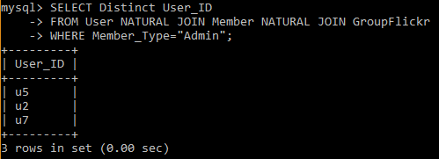

* It keeps track of popular personalities or figures by analyzing number of their followers.

Query2: Find the name of all the users having more followers than the people they follow

**SELECT** Name

**FROM** User **as** T

**WHERE**( (**SELECT** count(*) **from** User **NATURAL JOIN** followed_by **where** User_ID=T.User_ID) >

(**SELECT** count(*) **from** User **NATURAL JOIN** follows **where** User_ID=T.User_ID));

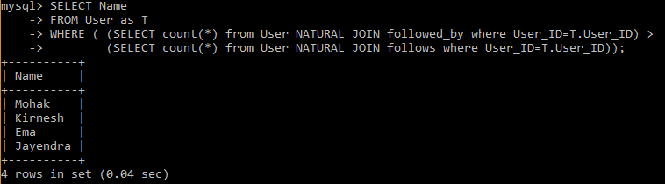

* It keeps track of favorite photos in the favorite tab (Favorite photos is that one which is liked by his own user).

Query3: Find favorite photos of user ID u1.

**SELECT** Photo_ID

**FROM** Photo

**WHERE**User_ID=”u1” **and**

Photo_ID in (**SELECT** Photo_ID **from** Likes **where** User_ID=”u1”);

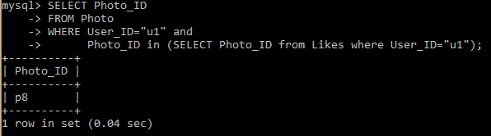

* It shows number of likes on the profile pic of each user and decides whose profile pic is trending.

Query4: All users having number of likes on their profile pic greater than 2.

**CREATE VIEW** PP **as**

(**SELECT** Photo_ID, User_ID **as** PPUser

**FROM** User **NATURAL JOIN** Profile_Pic);

**SELECT** PPUser

**FROM** PP **JOIN** Likes **on** Likes.Photo_ID=PP.Photo_ID

***group by*** PPUser

***having*** count(Likes.User_ID) > 1;

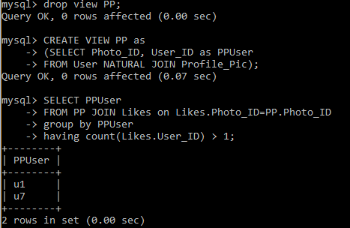

* It also shows in the groups tab in which group you are joined

Query5: Show the names of groups joined by any particular user with User_ID “u2”.

**SELECT** Group_ID,Group_Name

**FROM** GroupFlickr **NATURAL** **JOIN** Member

**WHERE** User_ID=”u2”;

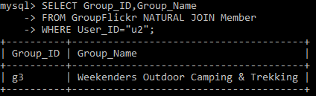

* It shows top contributors from each group.

Query6: List the top contributors of each group along with user ID and group ID.

**CREATE VIEW** TopGroup **as**

(**SELECT** GroupFLickr.Group_ID,User_ID,count(Photo_ID)as countphoto

**FROM** Photo **NATURAL JOIN** Belongs_to_Group,GroupFlickr

**WHERE** GroupFlickr.Group_ID=Belongs_to_Group.Group_ID

***group by*** GroupFlickr.Group_ID,User_ID);

**SELECT** Group_ID,User_ID

**FROM** TopGroup as TG

**WHERE** countphoto >= **all**(**SELECT** countphoto **from** TopGroup **where** TopGroup.Group_ID=TG.Group_ID);

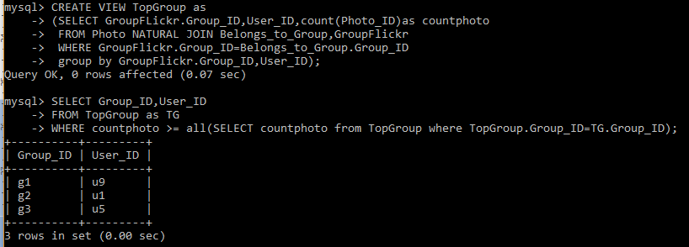

Query7: List all the users whose Privacy of all the photos in any of their album is marked as private.

**SELECT** User_ID

**FROM** Album

**WHERE** Album_ID in (**SELECT** Album_ID **FROM** Album as al

**WHERE EXISTS (Select** * **From** Belongs_to_Album **natural join** Photo

**where** Album_ID=al.Album_ID and Privacy=”Private”));

